**Regression Review Self-Test**

1. What do variance and standard deviation represent?
2. What is a sampling distribution?
3. What is the difference between the standard deviation and standard error?
4. What role does the standard error play in the confidence interval?

CI = b +/- (SEb)(t-value)

1. What are the definitions of covariance and correlation?
2. What does it mean to say that a regression line is a conditional average?
3. Explain the “intuitive” regression slope as an input, output function.

Slope = cov(x,y) / var(x)

1. How does the regression line split the variance of Y into the explained and unexplained portion?

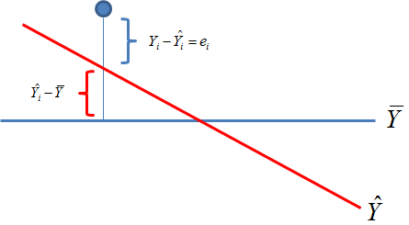

1. What are the three parts of the standard error of the slope?

$${SE}_{b}=\sqrt{\frac{residual}{sampSize∙var\left(x\right)}}$$